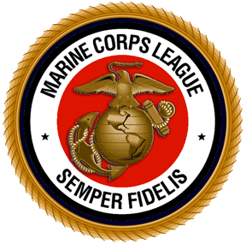
DetName Det. # xxxx, Marine Corps League
% Paymaster Name (Paymaster)
Street Address
City, NC zip+4

Dept. of North Carolina Marine Corps League
% Scott Shermeyer (Paymaster)
208 Hollywood Blvd
Havelock, NC 28532-2321

